**DHCP**

**Configuring Dynamic Host Configuration Protocol (DHCP)**  
You can have an IP address and the other information automatically assigned to the hosts connected to your network. By using DHCP, you can ensure that every host on your network has a valid IP address, subnet mask, broadcast address, and gateway, with minimum effort on your part.You should have a DHCP server configured for each of your subnets.Each host on the subnet needs to be configured as aDHCP client.

**Setting up the server file dhcp-2.0pl5-1.i386.rpm**  
rpm command from a command prompt to install it.DHCP server is controlled by the text

file/etc/dhcpd.conf.

start it by running the command dhcpcd. Each of your clients will now receive its IP address, subnet mask, gateway, and broadcast address from your dhcp server.place it in the /etc/rc.local file. Now whenever the system starts, this daemon will be loaded.

After you have **set up your first DHCP Scopes**, the next step is to configure DHCP Options. What does this mean; Simply put, you set what the individual options of a DHCP client, such as Gateway, DNS, etc., will be when it receives an IP address.

**Configure DHCP Options at Server level**

In the DHCP console, expand IPv4 and find the **Server Options** folder. Here, you’ll see all the settings you’ve already added at the server level.

already added at the server level.

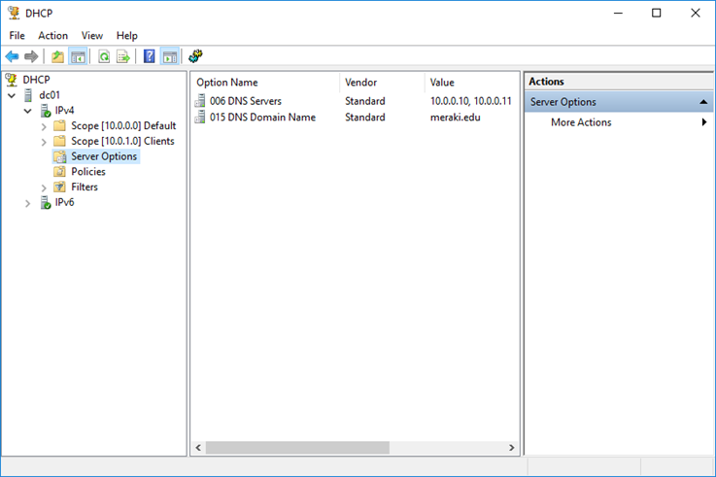

To add a new option, right-click **Server Options** and then click **Configure Options**.

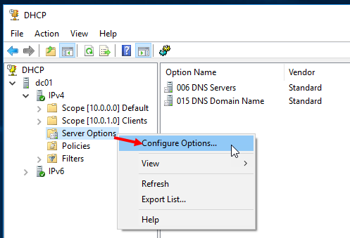

In the window, check one or more options and specify its value in the **Data entry** box. For example, the following figure shows the addition of the Router.

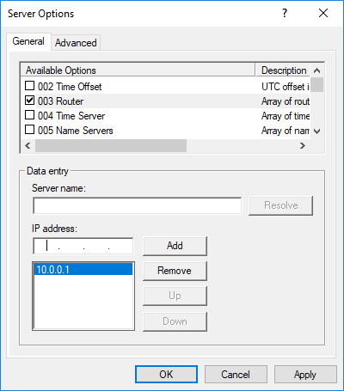

## Configure DHCP Options at Scope level

From the same DHCP console, expand a Scope and go to the **Scope Options** folder where you will find all the options you have set for this Scope.

To add a new option, right-click **Scope Options** and then click **Configure Options**.

**Linux**

Any system or network administrator working in large, busy computing environments will often find it hectic to set up new clients and assign them IP addresses and an array of other configuration parameters. This is where DHCP or Dynamic Host Configuration Protocol comes in handy.

DHCP or Dynamic Host Configuration Protocol is a client-server protocol that automatically and dynamically assigns IP addresses and other configuration parameters to devices within your network.

 Many computers do not have IP addresses when they boot up—unless they have a dedicated static IP address.

After booting, a machine will use the automatic**DHCP Discover** component to send a broadcast. The DHCP server will respond to the request or broadcast and contact the client using the **DHCP Offer** unicast traffic. The DHCP Offer traffic carries the designated IP Address assigned to the client. It also contains the server’s DNS IP address and the Default IP Address for the Gateway.

The client will consequently send a DHCP Request to the server acknowledging receipt and acceptance of the configuration parameters. The servers will keep records of all assigned addresses to prevent IP address collisions or double assignments. For local networks, there must only be a single server.

**Step-By-Step Guide on How to Configure DHCP Server on Ubuntu**

You need to follow these steps to configure a DHCP server to your Linux system:

**Step 1: Ensure that Your Systems Meet All the Specifications**

First off, ensure that your system meets all the necessary prerequisites. They include:

* You have two computer systems, both running Ubuntu 20:04
* Privilege to access your network as a root user with the ability to use the sudo command

**Step 2: Install DHCP Server**

On your designated DHCP server machine, install the DHCP server. Notably, the DHCP server package comes in the Ubuntu default depository. You will use the following command to implement the installation:



## Step 3: Start Your DHCP Service

Start your DHCP service to enable it to start at system reboot. You can accomplish this using the following commands:

## Step 4: Configure the DHCP Service

The DHCP configuration file is available at /etc/default/isc-dhcp-server. You can edit the file with the correct details to specify your network interface. The below command will help you achieve this:



You can specify your network using this command:



Proceed to save and close the file once finished. The next step is to edit the configuration (/etc/dhcp/dhcpd.conf) file to define your DHCP lease. The below command should be used:

The final step when configuring your server is to change the lines below appropriately:

Save and close this file once you finish editing everything.

## Step 5: Configure the DHCP Server for Static IP Address Assignment to Clients

The DHCP server has a default configuration to assign dynamic IP addresses to clients within the network. However, you need to configure your server to give static IP addresses to DHCP clients based on each client’s MAC address.

For instance, we can assign 192.168.21.02 to a client with the 4c:bb:58:9c:f5:55 MAC address. Edit your /etc/dhcp/dhcpd.conf file using the nano command as shown below to achieve this.



You should add the following lines to the file:

Save the changes and close the file.

It is time to restart your DHCP service to implement the changes. You can use the below command to restart the service:



Proceed to verify the status of your DHCP service with the command below:



## Step 6: Configure Your DHCP Client Instance to Obtain a Static IP Address

Once you set up your server, you will also need to set up your client instance. The first setup procedure is to ensure that your client can obtain a static IP address from the server.

To achieve this, open your client machine. We assume your client machine has the 4c:bb:58:9c:f5:55 MAC address. Once at the device, edit its network interface using the command below:



You can edit the interface by striking off the following default lines:

Save the changes and close the file. Now, to ensure that you apply the relevant changes n the new file, you can restart your Network Manager service using the command below:



The next step is to run the command below on the client machine:



The output should be as follows:

Sometimes, you may fail to get the IP address from your DHCP server. If that is the case, you can obtain it by running the command below:



You can verify the IP address by running the command below:



## Step 7: Configure Your DHCP Client Instance to Obtain a Dynamic IP Address

You can also configure your other client machine to obtain a dynamic IP address from your DHCP server. You can begin this process by first editing your network interface file using the command below:



Add the below lines to the file:

You can save and close the file. Now, to ensure that you implement the changes on the interface, proceed to restart your Network Manager using the below command:



Verify the dynamic IP address assigned to your DHCP client by running the following command:



The output should be similar to what is in the illustration below:

The article discusses the entire process beginning with installing and configuring the DHCP server on Ubuntu. We also discussed configuring the client instance to obtain both dynamic and static IP addresses.

**Dhcp lease**

A lease is defined as **the time period for which a DHCP server allocates an IP address to a client**. The lease can be extended upon subsequent requests. If the client no longer needs the IP address, it can release the address back to the server before the lease expires.

the default DHCP lease time for home and guest networks is set to 25200 sec (7 hours). This is the amount of time allocated for IP leasing.

When 50% of the lease period has passed, the client will attempt to renew the lease or update the IP address information.

You can set the IP lease time in the router's web interface. This setting is located on the 'Home segment' page in the 'IP settings' section. To change the parameters of an existing home network segment in the 'IP settings' section, click 'Show DHCP settings' and set the required value in seconds in the 'Lease time' field.

Here is an example of setting a lease period of an IP address assigned automatically by the DHCP server of the Keenetic router and its renewal.

For example, let's set the IP address lease time for the main home network to 60 seconds (we purposely set such a short time in our example to show how the IP address lease mechanism works). Generally, the recommended time to lease an IP address is 48 hours (172800 seconds) to renew the IP address once a day.

After applying the specified parameters, clients will receive an IP address for 1 minute, after which they will send a request to the DHCP server for a new IP address every 30 seconds. To update the IP lease timer, disconnect and reconnect the network adapter (or disconnect the Ethernet cable from the computer for a few seconds and then reconnect it).

This mechanism is clearly visible from the network packet dump collected on the DHCP client side. On the screenshot below, you can see that after 30 seconds there is a request to update the IP address.

You can also set the IP address lease time with a special command through the command-line interface (CLI) of the router:

**ip dhcp pool _WEBADMIN lease xxx**

where xxx is the time in seconds. The maximum value of the IP address lease in KeeneticOS is 259200 seconds (72 hours, 3 days).

To save the settings to the non-volatile memory of the router, run the command.

**system configuration save**

**Additional Info**

A DHCP lease is a temporary assignment of an IP address to a device on the network. When using [DHCP](https://www.efficientip.com/what-is-dhcp-and-why-is-it-important/) to manage a pool of IP addresses, each client served on the network is only “renting” its IP address. Thus, IP addresses managed by a DHCP server are only assigned for a limited period of time.

The period of validity of the assignment is called a lease duration and when it expires, the client shall immediately stop using this IP address and stop all communication on the IP network. The main risk of not complying to this rule is to have more than one device on the network using the same IP address with conflicts on delivering IP frames to the right device (aka duplicate IP address).

DHCP lease duration is expressed in seconds. It can be specified as “infinite” for permanent leases, usually used for devices that should not change their IP address without a need to change their configuration (some IOT, printers or application servers).

Depending on the lease duration, clients on the network may need to continue using the same IP address, therefore need to extend the lease period. Half way through the lease time (T1 timer), the client can contact its DHCP server in order to extend its lease period via a lease renewal request. This renewal process can be performed multiple times if no answer from the server has been received. If for any reason the renewal of the lease hasn’t worked by 7⁄8 of the way through the lease duration (T2 timer), the client can try rebind its lease via a broadcast to any DHCP server on the network. If the whole process has been unsuccessful before expiration of the lease period, the client should stop using its IP address and go through the whole process from the beginning.

During the DHCP lease period, the client can ask the server for a lease termination, in order to free the IP address so that it can be used for another client on the network. This process is generally automatically performed when a host shuts down.